CYBR 520
Lab 2: Statistical Classification & Decision Trees (Python version)
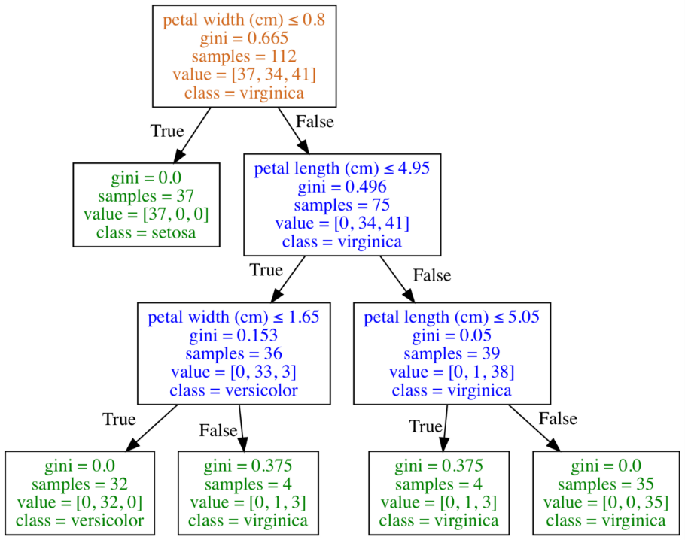
Dataset: Spambase
Topics: Statistical classification, decision trees, accuracy assessment, metrics, confusion matrix
Python Libraries: pandas, scikit-learn, seaborn, matplotlib, numpy
Decision Trees (Figure 1) are among the simplest of supervised classification techniques. The advantages of decision trees is that they are very easy to interpret and understand, relative to more complex classifiers like artificial neural networks, convolutional neural networks (CNNs), and Generative Adversarial Networks (GANs) which are often referred to as “blackboxes”.
Figure 1 – Decision Tree diagram. Classification of Iris data
Background: The spambase dataset is a classic example dataset for exploring machine learning applications for developing cybersecurity controls (specifically spam filters). The spambase dataset was developed in 1999 by Mark Hopkins, Erik Reeber, George Forman, and Jaap Suermondt of Hewlett-Packard Labs. The spambase dataset is a corpus of spam emails and non-spam (“ham”) emails. 4601 unique instances comprise the dataset. Each instance contains 57 unique attributes which can be used to train machine learning algorithms to automatically classify the data as “ham” or “spam”. It is commonly assumed that this dataset does not contain any error, and all 4601 instances are correctly labeled based upon expert knowledge.
Our objective for this lab will be to construct a rudimentary unpruned decision tree classification of the spambase dataset. This decision tree classifier will effectively serve as a spam filter (albeit, a vary narrowly tuned one).

Lab Structure
The first part of this lab is a walkthrough with basic questions. Note that a companion walkthrough video is available on eCampus. Please answer each of the questions after the associated section of the walkthrough.
The second part of the lab, is where you will explore the data and test your analytics capabilities. Answer each question fully, and present all code and plots associated with answering each question.
Reproducibility of your code and your analysis to answer the questions are important, so include those as part of your companion walkthrough or README file with your lab submission.
REMEMBER: Take your time with this. Don’t just rush through to complete the lab. Understand what you are doing, and how to leverage analytical techniques and software to solve cybersecurity problems. This lab is meant to expand your knowledge and skillset, not just for a grade…

Import the spambase dataset into Python

Start by downloading the spambase .csv file from eCampus.
Start VSCode and Launch a terminal. Start by loading your csv file into python using pandas.
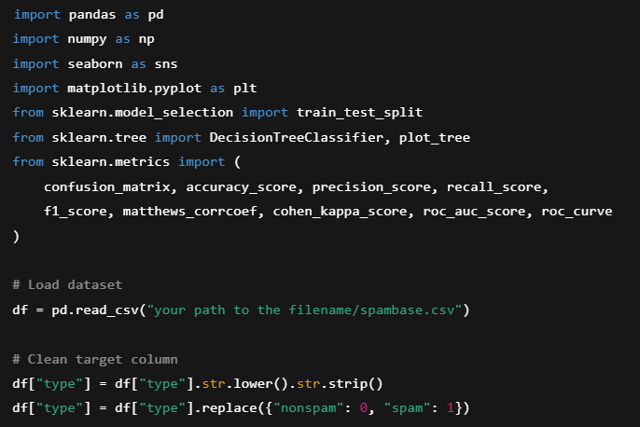

Question 1: How many observations now exist within each dataset? Does each dataset contain the same number of attributes or dimensions? Why do you think that’s important?
Now we can start constructing our decision tree classifier.
The first thing we need to do is to split our dataset into training and testing data. The training data will be used to train our decision tree model, while the testing dataset is set aside and used to measure the trained models effectiveness on “new” data. In essence, the test dataset is what we will use to evaluate the accuracy of our machine learning classifier. Since we only have one dataset (the spambase dataset), we’ll need to split the spambase dataset itself into training and testing partitions, so we can hold out the testing partition for the accuracy assessment.
There is no defined rule in the machine learning community and in the scientific world that says you need to use a specific proportion for splitting a dataset into training and testing, but a common threshold is 70% training, 30% test. This is called the “holdout” method and is the most simplistic of method of evaluating a classifier.

Partition the dataset into training and testing sets
To partition the dataset into training and testing sets, we can use the createdatapartition function built into the caret package. Before we split the dataset though, we need to ensure that we have set a seed value. This seed value is important for consistency and replication. The seed value gives a starting point for some of the “random” or “pseudo random” functions in R. It’s very important that you use a single seed value, and use it consistently, this ensures replication in your study, which is very important for robust scientific analyses.
We’ll use a 70/30 split (hold-out method). Setting a random seed ensures reproducibility.
You don’t need to use 42, you can pick any number, just be sure you use the same number throughout your analysis, and you remember the number you used.
(I like 42 though – it’s the answer to life, the universe and everything – if there’s any Hitchhiker’s Guide to the Galaxy fans out there.)
Here is code to split the dataset into training and testing proportions at 70% and 30%, respectively:
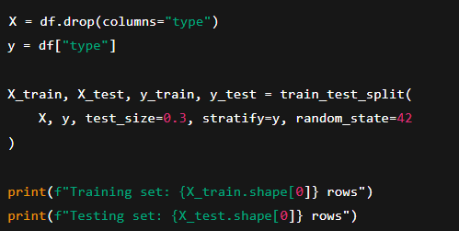
Question 2: Which of the following attributes are used to identify which observation is classified as “nonspam” or “spam”?

Construct the Decision Tree model
Now we need to construct our decision tree model. Building a simple decision tree model using the DecisionTreeClassifier is actually very easy.
Type:
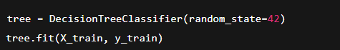
Now let’s visualize the tree
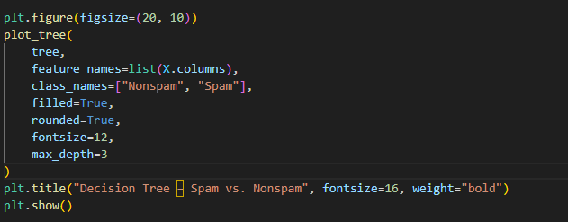

Question 3: Which of the following attributes are used to identify which observation is classified as “nonspam” or “spam”?

Question 4: Post a screenshot of the decision tree plot. What are your observations about this decision tree plot. What variables/attributes were used to differentiate between spam and nonspam?

Now lets take a look at the importance of each variable according to the decision tree classifier. To view the variable importance type:
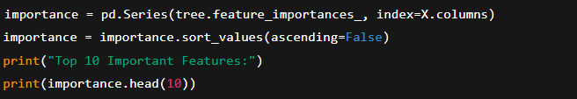
Question 5: What were the top 10 ranked variables in order of importance (the higher the value, the more important the variable to the classifier in this case)

Question 6: Why do you think insights on the importance of each variable is critical towards research and development of spam filters?

Question 7: Do you think this analysis alone will be enough to determine if these variables are universally important in spam filtering?

Accuracy Assessment
What good is a machine learning model if you can’t measure how well (in this case, accurate) it performed? Accuracy assessment is actually a hotly debated topic in the machine learning community, as there are a variety of ways to measure accuracy, and often, an accuracy assessment without context can be misleading. Personally, accuracy assessment in machine learning is actually a research area of mine, and you would be surprised how many peer-reviewed scientific studies do not employ robust accuracy assessment measures…
Remember that 30% of the data we held out in step 2? That’s our “test” data. Our decision tree model has not seen this data yet, so we’re going to test how well the model predicts on this new unseen dataset. That’s a good preliminary indicator of the model’s accuracy.
Our test dataset should still be stored as the list “Test”. So lets try to make a prediction on this new dataset.
To set up our prediction type:
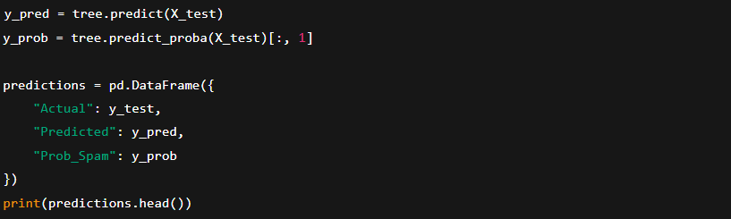

Question 8: What happened when outputting our prediction? What do you think each of these outputs mean? Is this very useful for measuring accuracy?

Let’s see if we can break down this prediction into a simple binary confusion matrix.
Notice I’m using the term “binary” matrix, because we only have two classes “spam” and “not spam”. We can have a multi class confusion matrix when we have more than two classes, However accuracy assessment gets a little more complex when we have multiple classes. Binary classification problems are luckily straightforward.
To set up the confusion matrix, type:
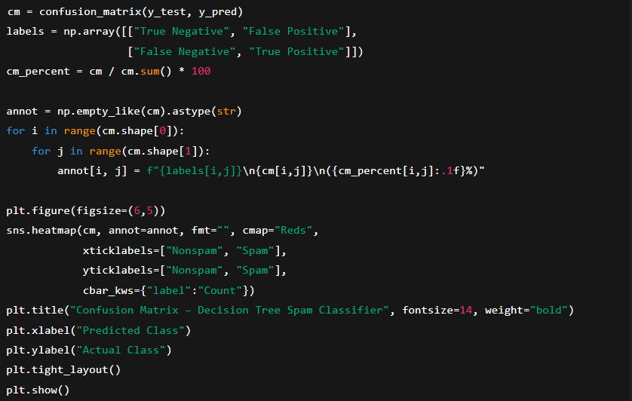
Question 9: What are the results of the classification?

Now what do each of these values mean? In a binary confusion matrix:
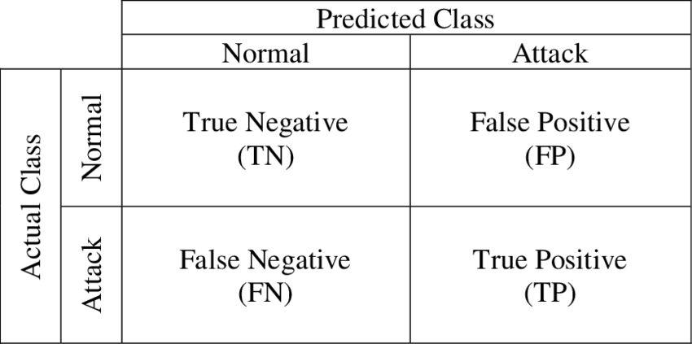

Question 10: Identify and describe what each of the binary classification results (i.e. True Negative) means in the context of our spam filter. For example: A false positive would be a non-spam instance that was mistakenly classified as Spam.

Now, while understanding how many true negatives and false positives and so on can be useful, we often like to use a metric to provide better insights on the performance of the classifier.
One of the most common measures is Accuracy (or Overall Accuracy).
Accuracy is defined as:
$$Accuracy= \frac{TP+TN}{TP+FN+TN+FP}$$

Question 11: What is the reported Accuracy of our decision tree model?
Question 12: Can you compute this in Python? What would be the code?

There are also several other metrics we can use for binary classification evaluation:
$$Precision= \frac{TP}{TP+FP}$$

$$Recall=\frac{TP}{TP+FN}$$

$$F1=2*\frac{ (Precision* Recall)}{Precision+Recall}$$

Question 13: See if you can write a brief function in Python to output the F1 score of your classification. Include the F1 score and your code below.

Question 14: Research and describe why the F1 metric can be useful, and how it differs from just using the Accuracy metric.

Question 15: See if you can construct a visual heatmap, similar to this, which displays the false positives, true positives, etc. Provide the code in your README file.
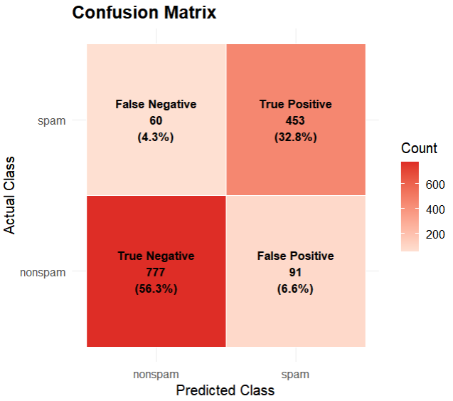

Question 16: Conduct some research on your own, look up some machine learning research in cybersecurity and see what metrics they use to evaluate their models? Is one metric dominant over another? Cite a paper or two that you looked at.

- Exploratory Section (Independent Classification)
Find or make your own cybersecurity related dataset, and run a decision tree classification, and accuracy assessment. Include all data (nothing malicious), code, and visualizations. Be creative!

https://towardsdatascience.com/understanding-decision-trees-for-classification-python-9663d683c952

